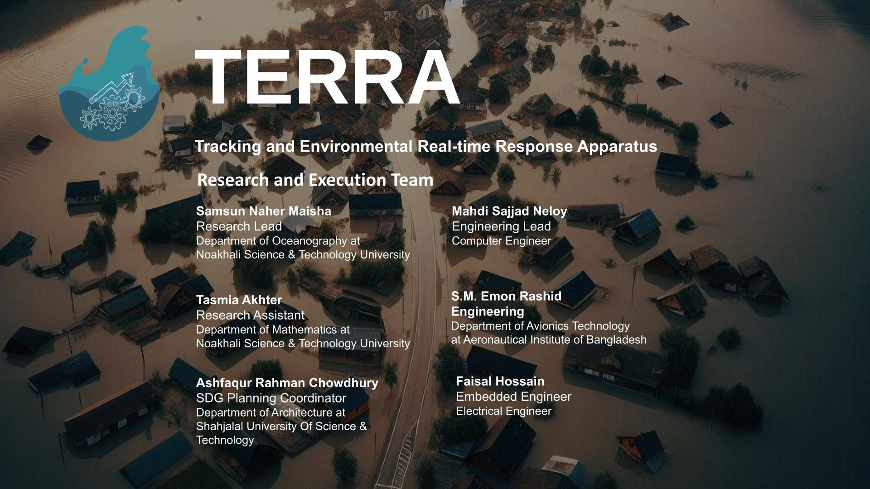

Project Proposal: TERRA

Title: TERRA – Tracking and Environmental Real-time Response Apparatus

Project Overview:

The project entitled "TERRA – Tracking and Environmental Real-time Response Apparatus" is an advanced, automated flood and environmental monitoring system designed to improve flood management and response capabilities. Each TERRA unit is developed to function autonomously, continuously gathering and transmitting real-time environmental data, including water levels, temperature, humidity, and air quality. The device incorporates a robust array of sensors for instance, ultrasonic and pressure sensor HC-SR04 for water level monitoring, the DHT22 sensor for temperature and humidity, and the MQ135 sensor for air quality. It has a three-layered power system with a combination of solar power, rechargeable batteries, and AC/DC backup options to ensure uninterrupted operation, even during extended flood events or power outages. Furthermore, it can ensure reliable data transmission across Bangladesh’s varied infrastructure, TERRA units support multiple connectivity options: Wi-Fi, GSM, and LoRaWAN. This project focused on non-structural flood management by installing a network of TERRA units across flood-prone regions to address flood risks proactively, minimizing loss and enhancing regional safety and sustainability. Based on initial success, TERRA’s platform is set to expand with further environmental sensors and predictive models. This project is anticipated to provide decision-makers with comprehensive situational awareness across Bangladesh—from soil conditions to river water quality. This expansion will enable informed agricultural, infrastructure planning and development in the floodplains and economic decision-making, which would foster both national food security and building resilient communities.

Problem Statement/ Background/Context:
Bangladesh, due to its unique hydrogeological condition, is generally known for its natural vulnerability to floods, cyclones, droughts, etc and particularly susceptible to climate change. Flooding is a frequent and catastrophic occurrence in Bangladesh that results in significant social and economic losses and damages throughout the nation each year. Between 1900 and 2016, Bangladesh experienced ninety significant flood disasters, leading to the loss of 52,437 lives and indirectly impacting approximately 32 million individuals. Floods impair everyday life, impacting property, agricultural land, daily activities, the state of the water supply and sanitation, and the economic structure. According to the National Disaster Response Coordination Center (NDRCC), approximately 5.8 million people in the northeastern and southeastern regions have been affected by recent flooding including Noakhali, Cumilla, Laxipur, Feni, Chattogram, and Moulvibazar, with over 1 million individuals currently isolated in flood-impacted communities. This is due to the climate change which has contributed to more erratic and extreme rainfall patterns, resulting in excessive rain over short periods as well as inadequate preparedness and real-time situational awareness, scarcity of response mechanisms, and unreliable infrastructure and resources, exacerbating the severity of the situation. While some urban areas may benefit from flood forecasting and warning center (FFWC) coverage under BWDB, remote regions are often inadequately served. Besides, underdeveloped or non-existent drainage infrastructure in local areas accelerates waterlogging during floods, and limited access to technological resources for real-time flood monitoring makes it challenging for authorities to issue timely alerts. The Bangladeshi government has contributed USD 2.5 million to flood early warning systems (FEWS). To continue maintaining installed capacity with designated authorities, national governments in developing countries often try to fill the financial insufficiency at the local level or add new revenue streams to their national budgets, but the amounts present serious obstacles. However, there are still no cost-effective real-time early flood monitoring devices deployed, particularly in remote sites that are at high risk of flooding.

Objectives:

- To deploy 10 functioning prototypes deployed in target locations
- To incorporate data insights to inform and influence the policy and action strategy development of the local government in taking climate actions
- To arrange a flood campaign and mapping literacy programme for the local communities

Proposed solution to address the problem or working Strategy:

- The collected data will allow for the small-scale tracking of climate change and offer major insights into the patterns of urban microclimates that influence air quality and flood risks.
- Unlike models reliant on historical data and forecasts, TERRA provides live, region-specific data that enables authorities to respond precisely, especially in dynamic flood scenarios such as flash floods.
- TERRA’s adaptability to Bangladesh’s connectivity and power limitations ensures consistent performance in locations where traditional systems might fail.
- Local governments may act to mitigate flood risk and climate resilience through integrating regular reports, consultations, and policy briefs into their decision-making on zoning regulations, infrastructure investments, and emergency preparedness plans.
- A cooperative network of knowledgeable stakeholders will be ready to take action on climate challenges by encouraging open communication and transparent data sharing.
- Community awareness programmes of flood risk management can enhance readiness and mitigate the effects of floods on vulnerable populations and increase local climate resilience.

Proposed working area:
The proposed study will be conducted on ten potential points at Noakhali Sadar upazila of Bangladesh.
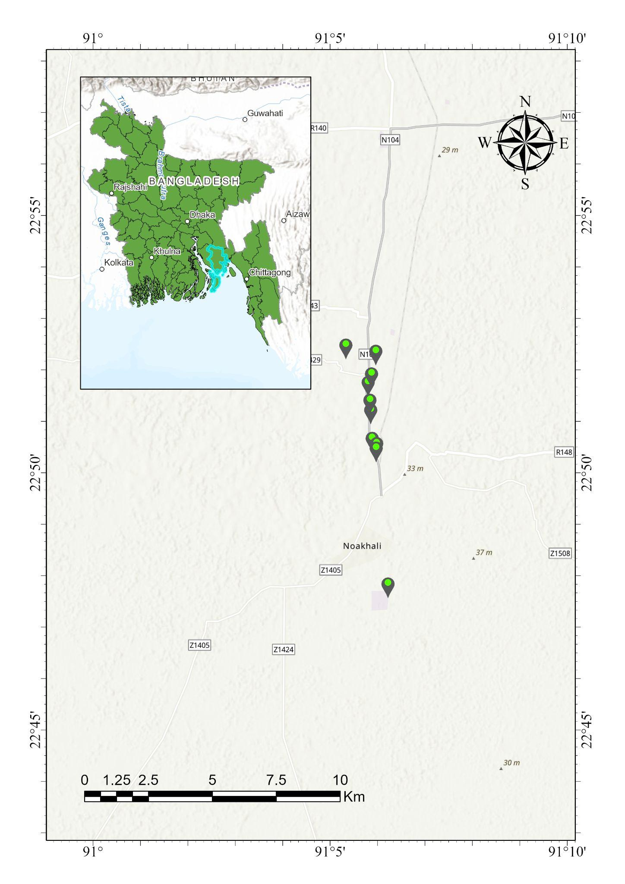
Fig.1 Tentative location of the proposed study

Impact:
The TERRA project aspires to substantially enhance resilience, disaster risk mitigation, and climate change adaptation in flood-prone areas of Bangladesh, with far-reaching advantages for communities, policymakers, and the environment.
Target Audiences: TERRA offers real-time environmental data crucial to multiple sectors. Government agencies use this data to enhance infrastructure planning, expedite disaster response, and support proactive policy-making to minimize flood impacts. Local authorities gain immediate flood insights to protect communities and coordinate emergency actions effectively. NGOs utilize TERRA’s data for resource-efficient disaster relief and enhanced resilience planning. In agriculture, TERRA guides farmers on crop planning to mitigate flood-induced losses. Research institutions gain access to high-quality data for advancing climate resilience studies, while construction and real estate sectors leverage it for safer site planning. Additionally, TERRA’s data aids international organizations in climate partnerships and insurers in risk assessment, serving both short-term response and long-term adaptation needs.
Short-Term Impacts
- Flood Preparedness and Real-Time Decision Support
TERRA’s real-time monitoring provides critical flood data to authorities, enabling swift responses and early warnings for communities. This preparedness minimizes risks to lives and property, ensuring communities are better equipped to handle flood emergencies.
- Resource Allocation
TERRA’s centralized dashboard enables precise targeting of resources to affected zones, ensuring prioritized support for vulnerable communities. This efficient allocation maximizes the impact of relief efforts, bringing timely aid to those in need.
- Community Awareness and Resilience
Flood campaigns and literacy programmes inform communities of local flood risks, fostering a culture of preparedness. This encourages preemptive safety measures, reduces panic, and enhances community resilience during flood events.
Long-Term Impacts
- Adaptation to Local Climate Change and Infrastructure Resilience
Authorities may monitor local climate change through ongoing data gathering, which informs resilient infrastructure and urban development. Bangladesh's ability to create climate-adaptive communities ready for future catastrophes is strengthened by data-driven advancements.
- Economic and Social Stability
TERRA strengthens economic resilience in vulnerable areas by minimizing flood-induced losses, which lowers recovery costs and promotes regional development. This stability protects investments and improves the standard of living for locals.
- Sustainable Agriculture Production
TERRA’s data on soil moisture and other conditions supports sustainable agriculture, crucial for food security. These insights will help rural communities reliant on farming to adapt to changing environmental conditions.
- Support for Proactive Policy Development
Ongoing environmental monitoring strengthens national climate resilience by supporting sustainable urban development, water resource management, and agriculture while enabling policymakers in adapting to climate hazards.
- Long-Term Risk Management
TERRA’s predictive capabilities help identify high-risk zones by flood zone mapping and track flood trends, supporting resilient infrastructure planning. Data-driven mitigation measures, such as flood barriers and buffer zones, reduce disaster risks and enhance community resilience across Bangladesh

7. Activity List:
The 6 month activity plan of project TERRA is given below:
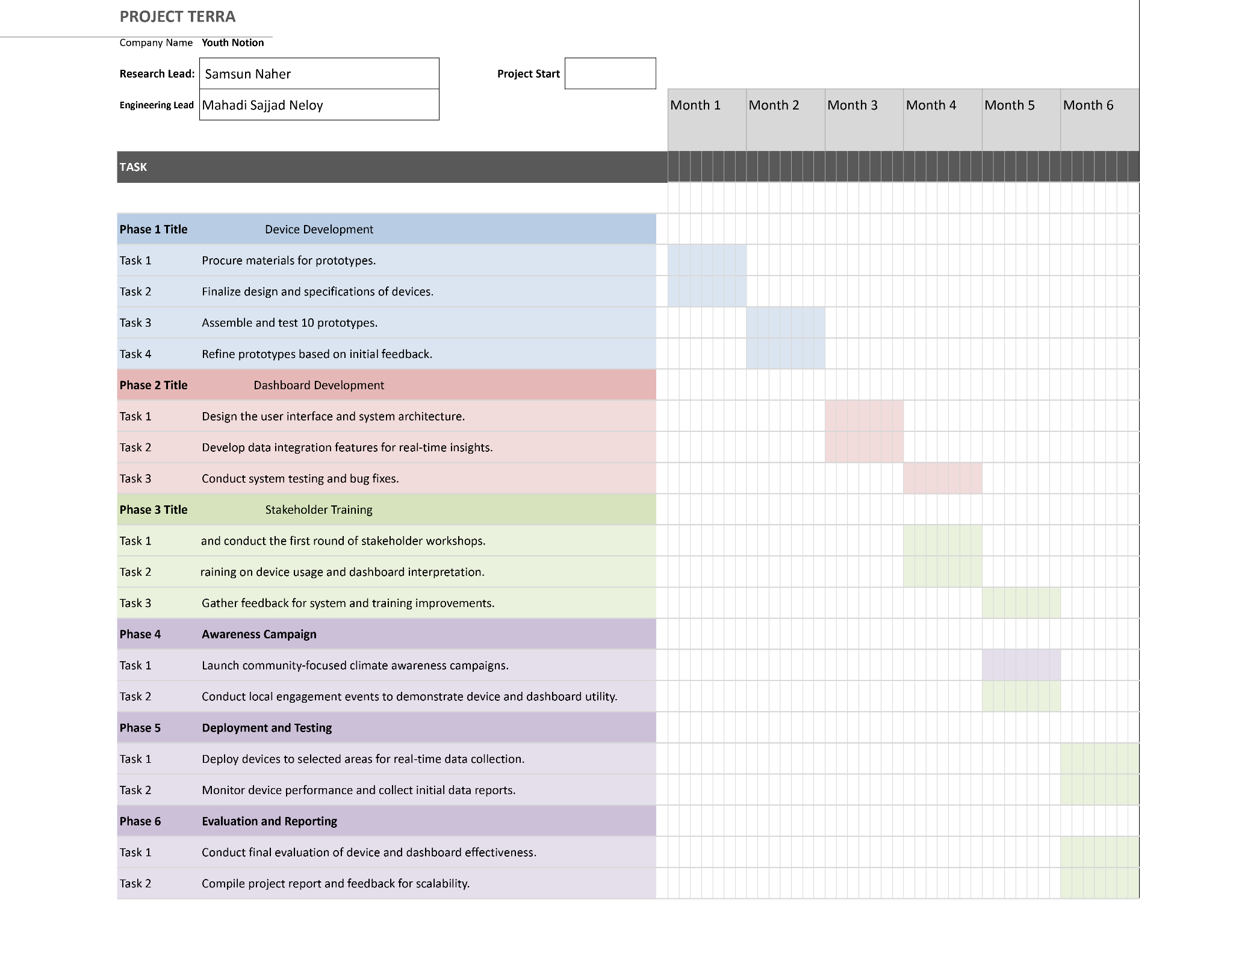

The Phase wise activity of project TERRA is given below:
Phase 1: Network Deployment | Phase 2: Data Collection and Integration | Phase 3: Analytical Dashboard Development | Phase 4: Stakeholder Engagement and Training | Phase 5: Policy Influence and Action , Scaling
(Months 1-4) | (Months 5-8) | (Months 9-12) | (Months 13-15) | (Months 16-18)
Objective: Establish the hardware infrastructure to collect microclimate data across target urban areas. | Objective: Set up data collection protocols and integrate data into a central system for analysis. | Objective: Develop and launch  user-friendly dashboards and APIs for data visualization and stakeholder access. | Objective: Educate stakeholders on the platform, promote awareness, and ensure effective utilization. | Objective: Collaborate with policymakers to leverage insights for urban planning and policy-making.
- Identify critical urban areas for climate monitoring device installation.  - Conduct initial site surveys and assessments to determine optimal placement of devices. | - Establish real-time data collection protocols, including data frequency, formats, and quality checks.  - Begin initial data collection from deployed devices and conduct preliminary assessments. | - Define user requirements for dashboards and visualization tools, focusing on usability and accessibility.  - Begin development of the interactive dashboard interface. | - Develop training materials and modules tailored to various stakeholder needs.  - Begin initial outreach and onboarding sessions with primary stakeholders, including city authorities and urban planners. | - Present data insights and key findings to policymakers.  - Collaborate with city authorities to integrate climate insights into urban planning considerations.

- Procure and test climate monitoring devices.  - Begin device installation at identified locations, focusing on high-priority areas.  - Ensure network connectivity for data transmission from devices. | - Develop a central analytical system for data aggregation.  - Integrate data feeds from devices into the central system, setting up automatic ingestion protocols. | - Integrate visualization tools to generate heatmaps and other visual representations based on  real-time data.  - Develop and test API for data sharing and compatibility with other systems. | - Conduct workshops and training sessions to demonstrate platform features and data interpretation.  - Gather feedback from stakeholders to identify additional needs or improvements. | - Support policymakers in drafting initial policies informed by microclimate data.  - Begin tracking policy adoption and identifying further areas for data-informed decision-making.
- Complete installation and calibration of monitoring devices.  - Perform initial testing of data transmission to verify network coverage and functionality. | - Conduct system testing to ensure smooth data flow and real-time data availability.  - Finalize the data storage and backup systems. | - Conduct user testing to gather feedback on dashboard functionality.  - Refine the dashboard and API based on user feedback and finalize the dashboard for deployment. | - Finalize stakeholder engagement programs and encourage ongoing usage of the platform.  - Promote awareness campaigns highlighting the value of microclimate data for urban resilience. | - Monitor and evaluate the impact of policy changes and interventions.  - Collect feedback from policymakers and stakeholders to guide future expansions or adjustments.  - Retaining fund and viable project sustenance measure for scaling.

8. Expected Outcome
- Get real-time microclimatic data of local areas and evaluate its performance in a real scenario.
- Operational online data dashboard for environmental insights.
- Recommend policy and action strategy to local govt for climate responsive development
- Flood campaign and mapping literacy programme for disaster response coordination system

